1. Deployment Overview

MosaicOne’s ElasticSearch Service was implemented as a microservice using SpringBoot. A docker image was created and pushed to docker hub. It can be deployed to the cloud using Kubernetes or Openshift. However this deployment instructions have opted to use AWS Fargate.

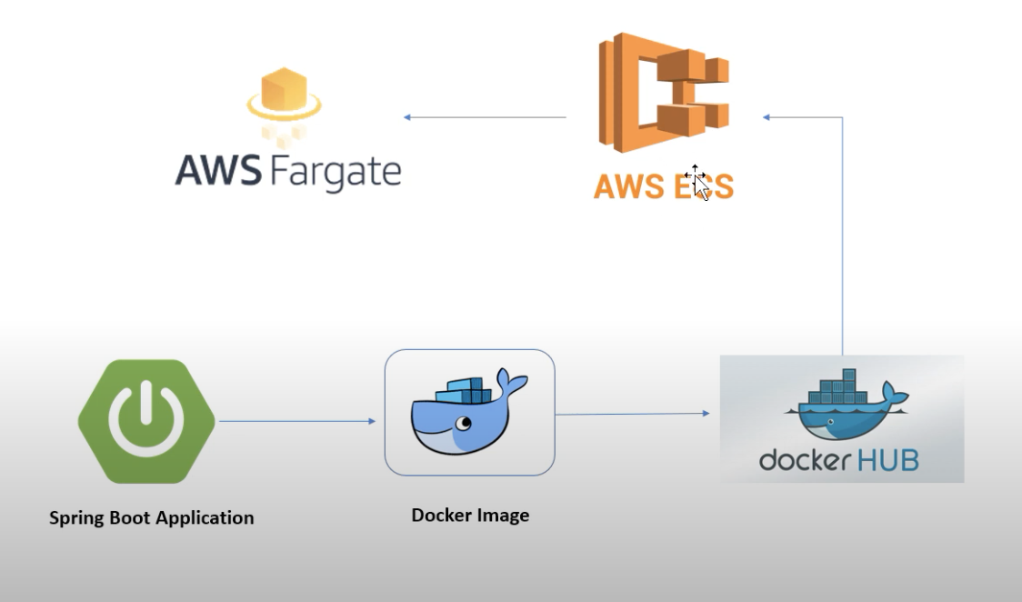

1. docker build MosaicOneElasticSearchService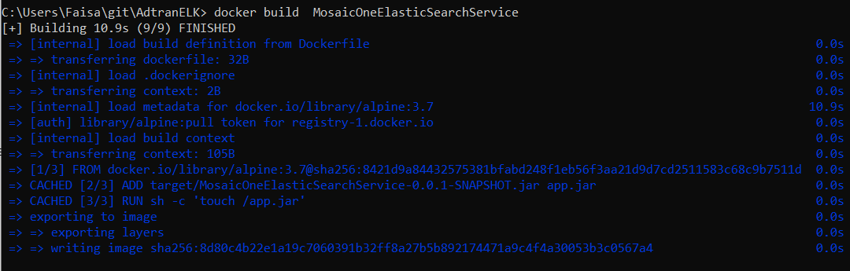
2. docker tag sha256:8d80c4b22e1a19c7060391b32ff8a27b5b892174471a9c4f4a30053b3c0567a4 faisalnkutu/mosaiceoneess
3. docker push faisalnkutu/mosaiceoneess

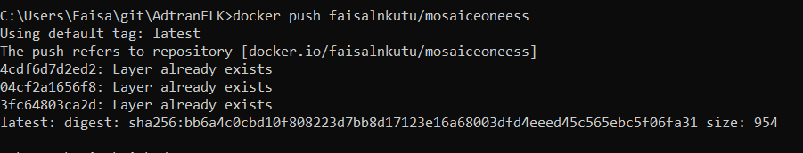

1. Image is pushed to docker hub <https://hub.docker.com/repository/docker/faisalnkutu/mosaiceoneess>

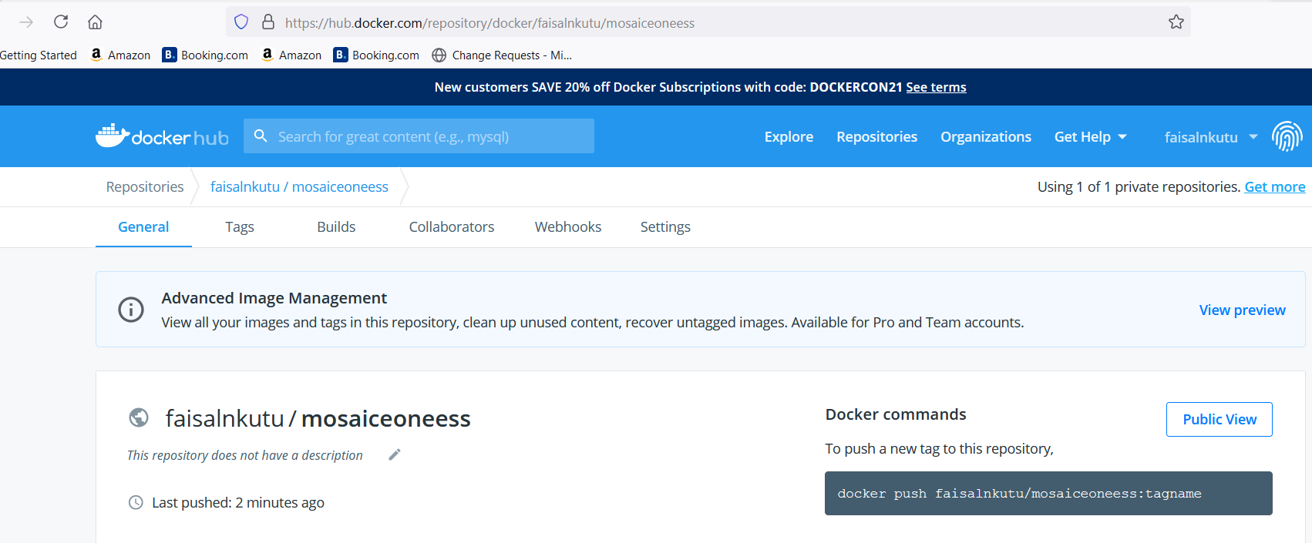

1. Login to AWS and Navigate to ECS

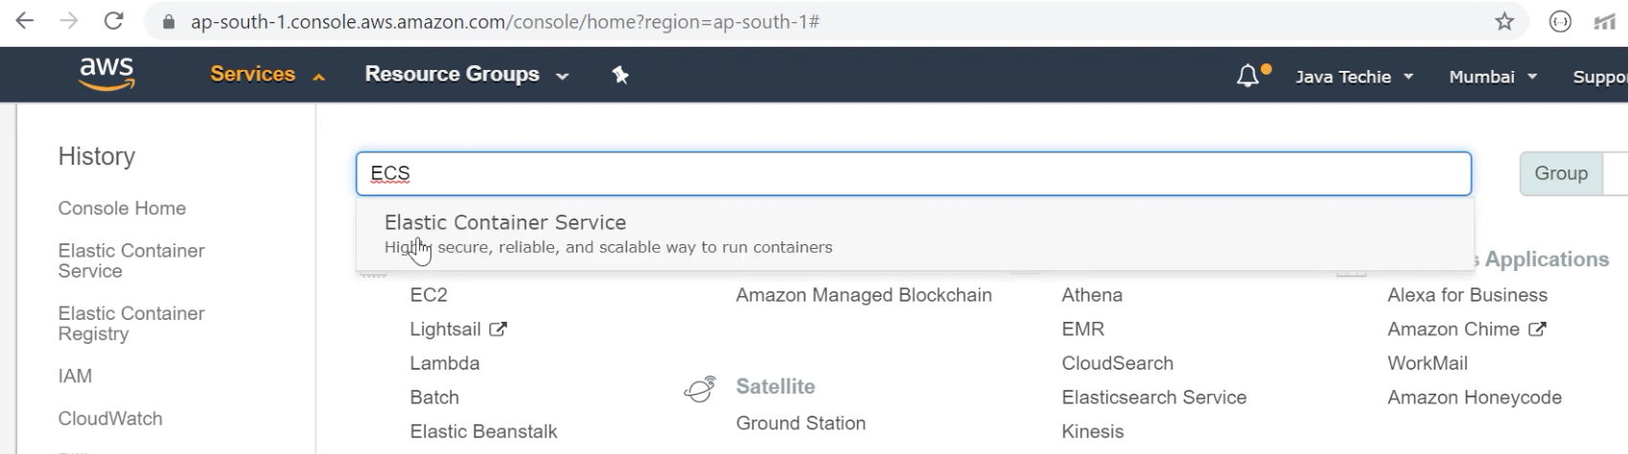

1. Create New Task Definition

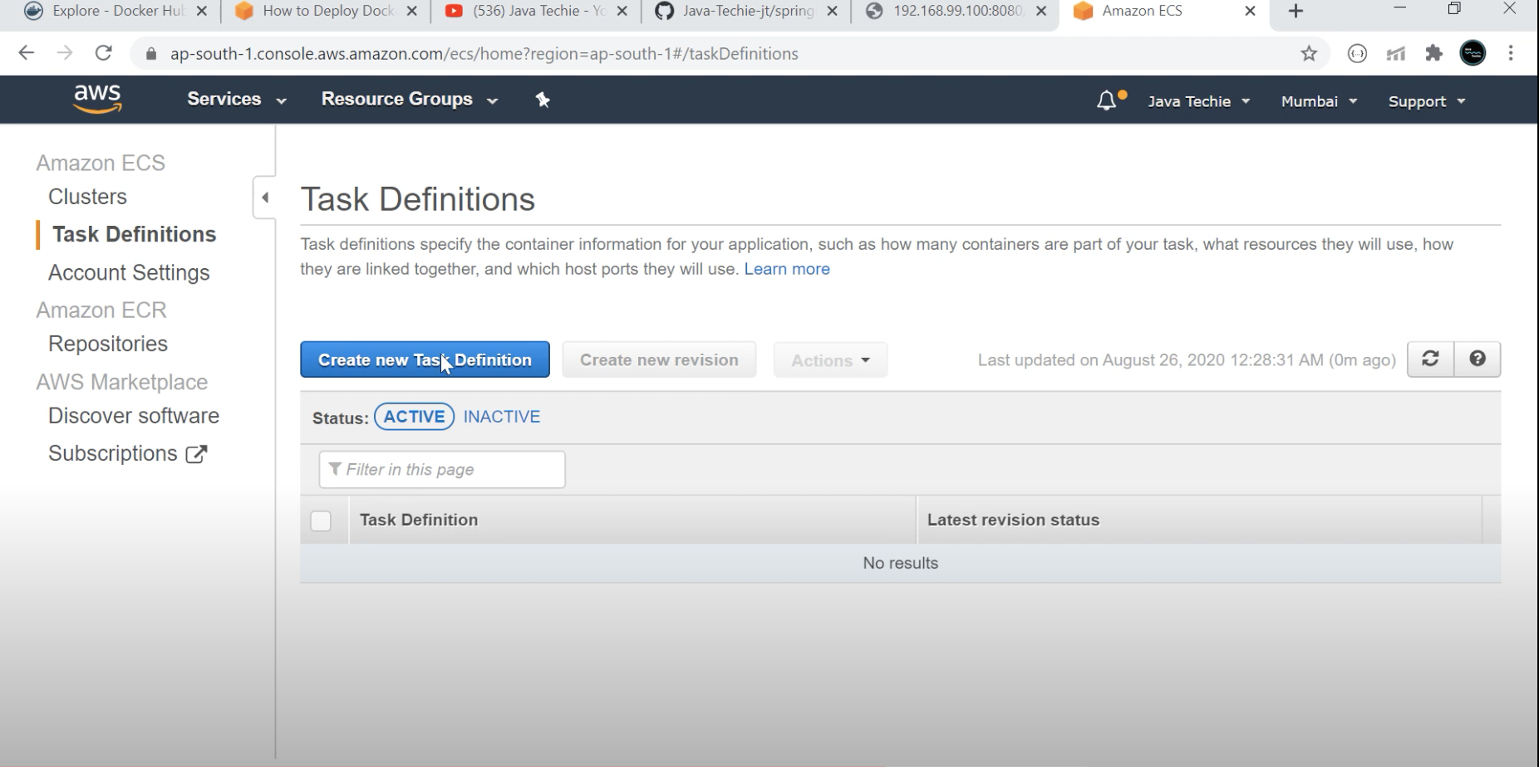

1. Create Fargate Task

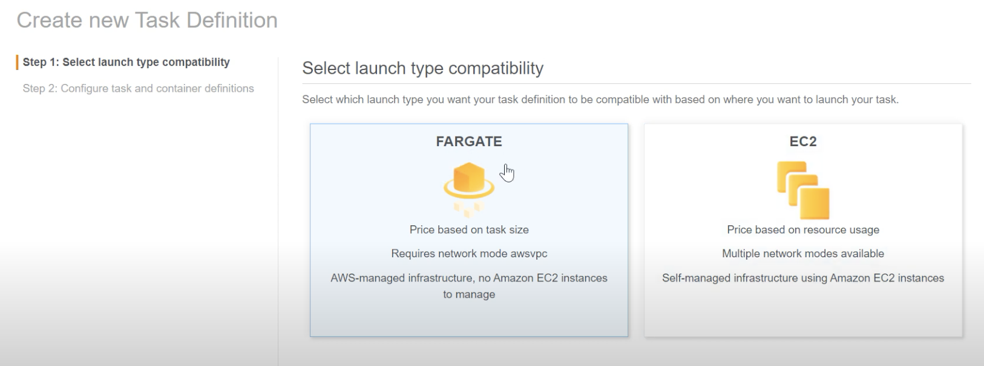

1. Provide Task Definition Name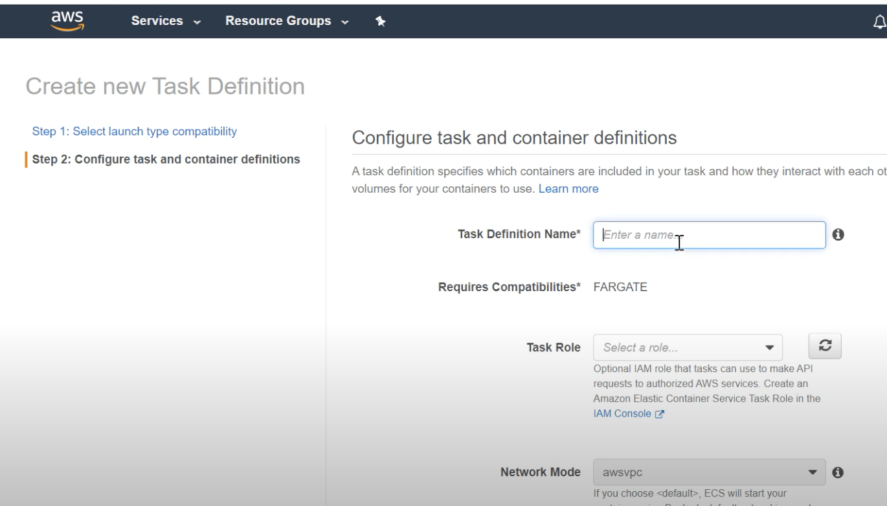
2. Specify Role. RAM, CPU and Container

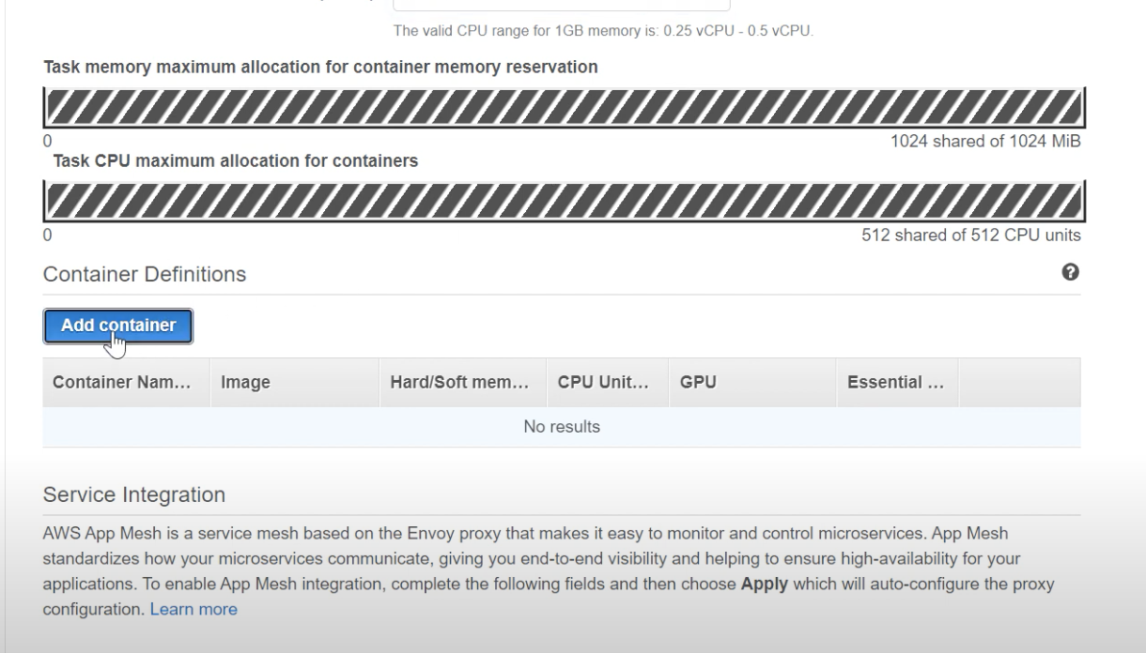

1. Provide Container Name and Add docker image <https://hub.docker.com/repository/docker/faisalnkutu/mosaiceoneess>

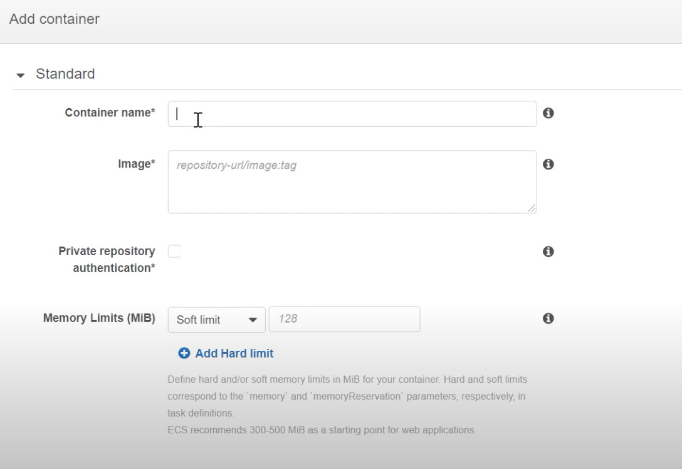

1. Specify Ports

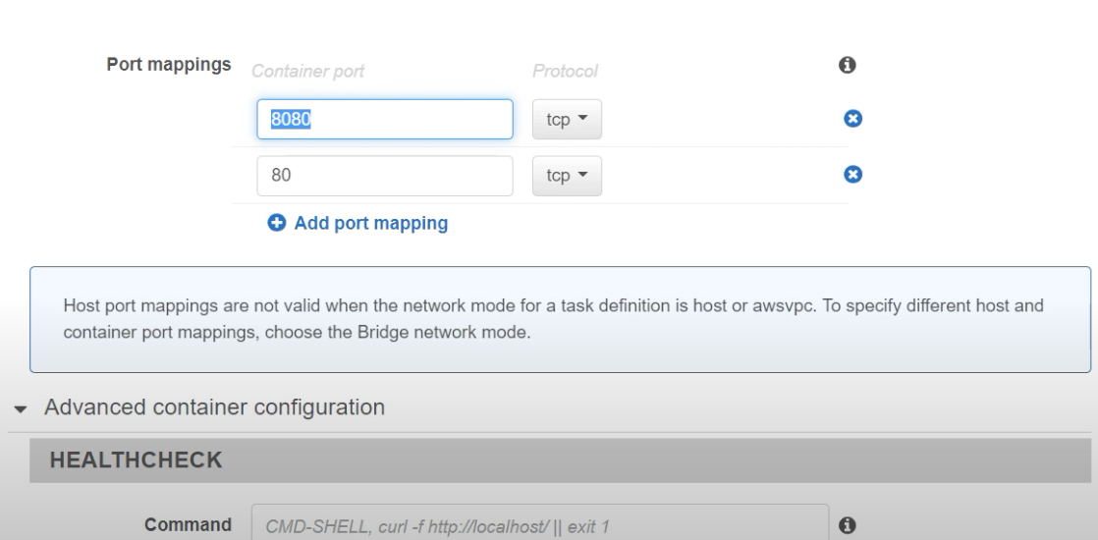

1. Create Cluster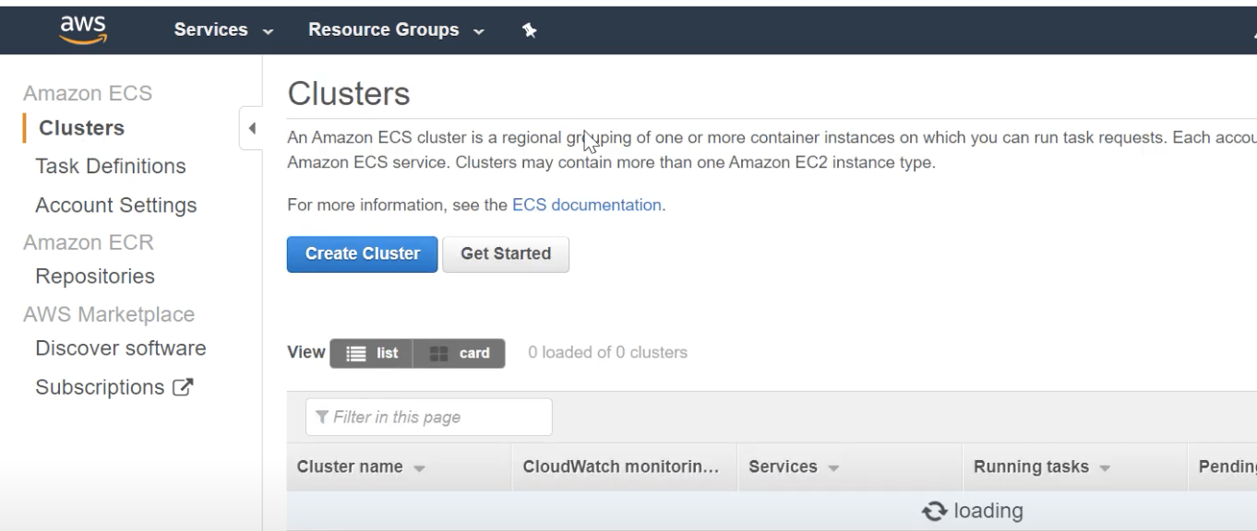

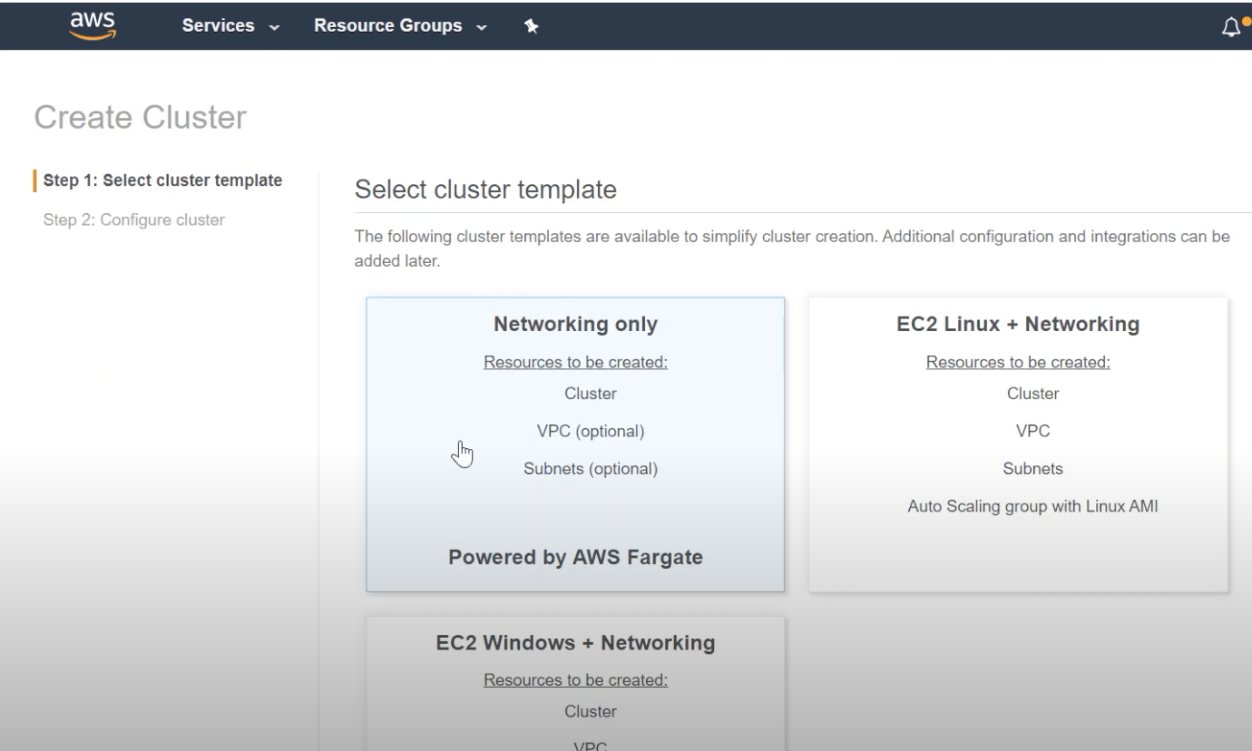

1. Provide Cluster name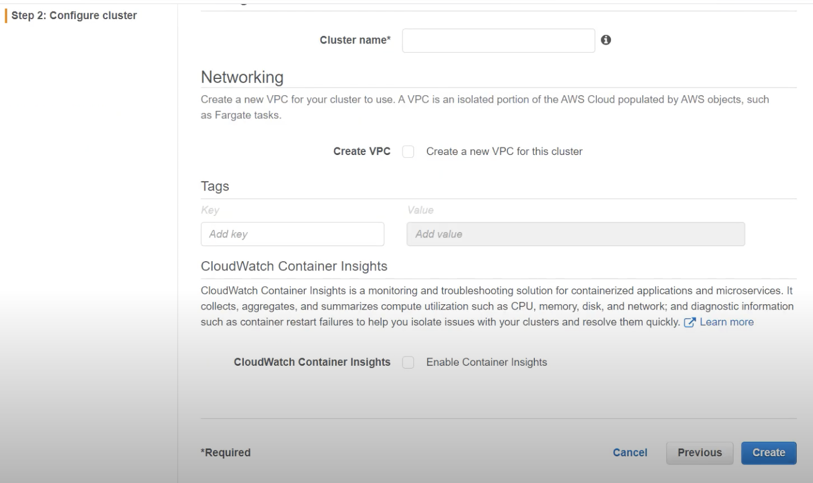
2. Add new Task to Cluster

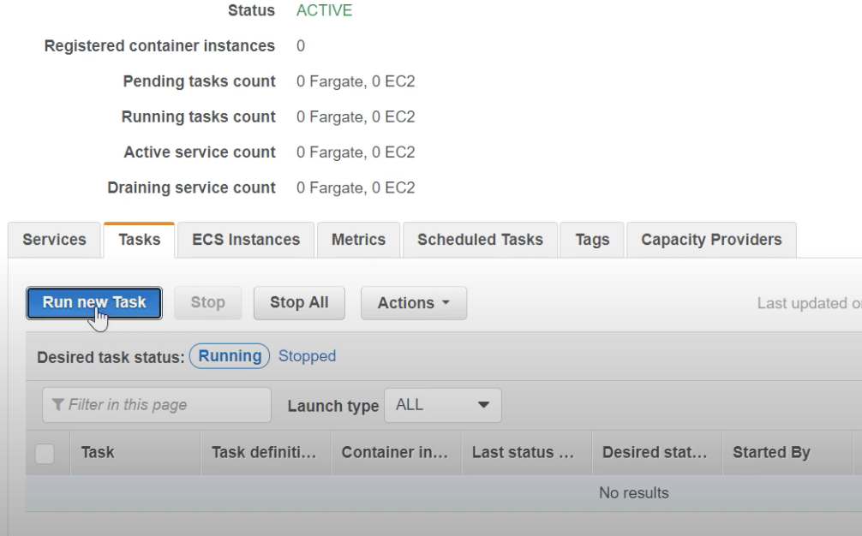

1. Select Default VPC and Subnet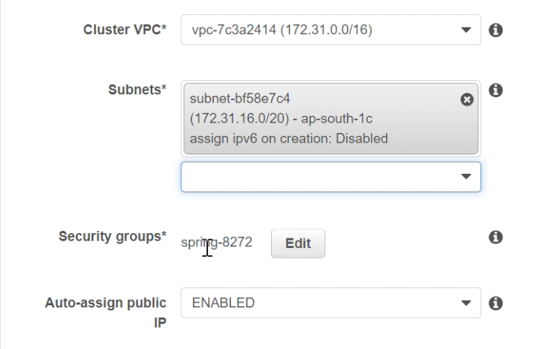
2. Configure Security Group

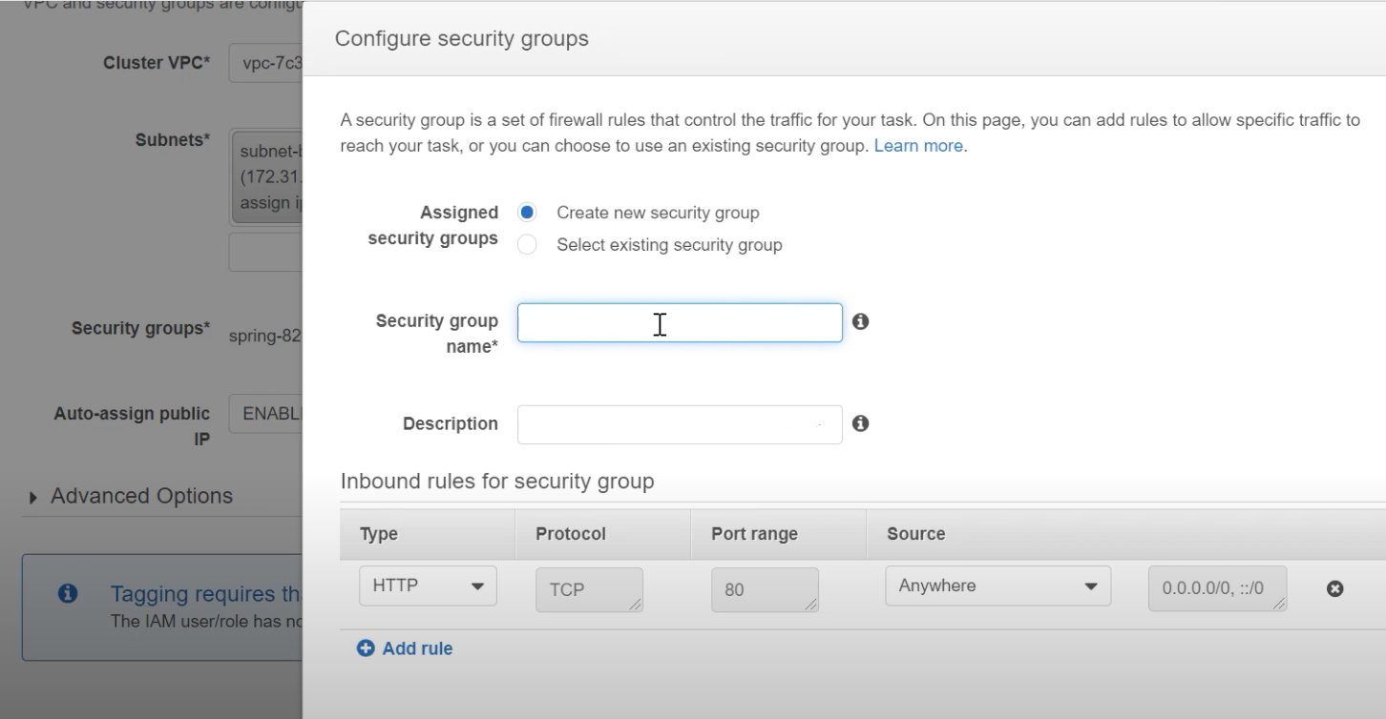

1. Specify inbound rules

